**Introduction to html/css**

1.How are inline and block elements different from each other?

Ans : Inline element

An inline element does not cause a line break (start on a new line) and does not take up the full width of a page, only the space bounded by its opening and closing tag.

For example: anchor <a> tag ,emphasis <em> tag,image <img> tag,span tag, etc.

Block Elements:

A block-level element always starts on a new line and takes up the full width of a page, from left to right. A block-level element can take up one line or multiple lines and has a line break before and after the element.

For example: heading tag, list tag , div tag, etc

2.Explain the difference between visibility:hidden and display:none

Ans: display:none means that the tag in question will not appear on the page at all (although you can still interact with it through the dom). There will be no space allocated for it between the other tags.

visibility:hidden means that unlike display:none, the tag is not visible, but space is allocated for it on the page. The tag is rendered, it just isn't seen on the page.

3. Explain the clear and float properties.

Ans: float property:

The float property is used for positioning and formatting content e.g. let an image float left to the text in a container.

The float property can have one of the following values:

* left - The element floats to the left of its container
* right- The element floats to the right of its container
* none - The element does not float (will be displayed just where it occurs in the text). This is default
* inherit - The element inherits the float value of its parent

In its simplest use, the float property can be used to wrap text around images.

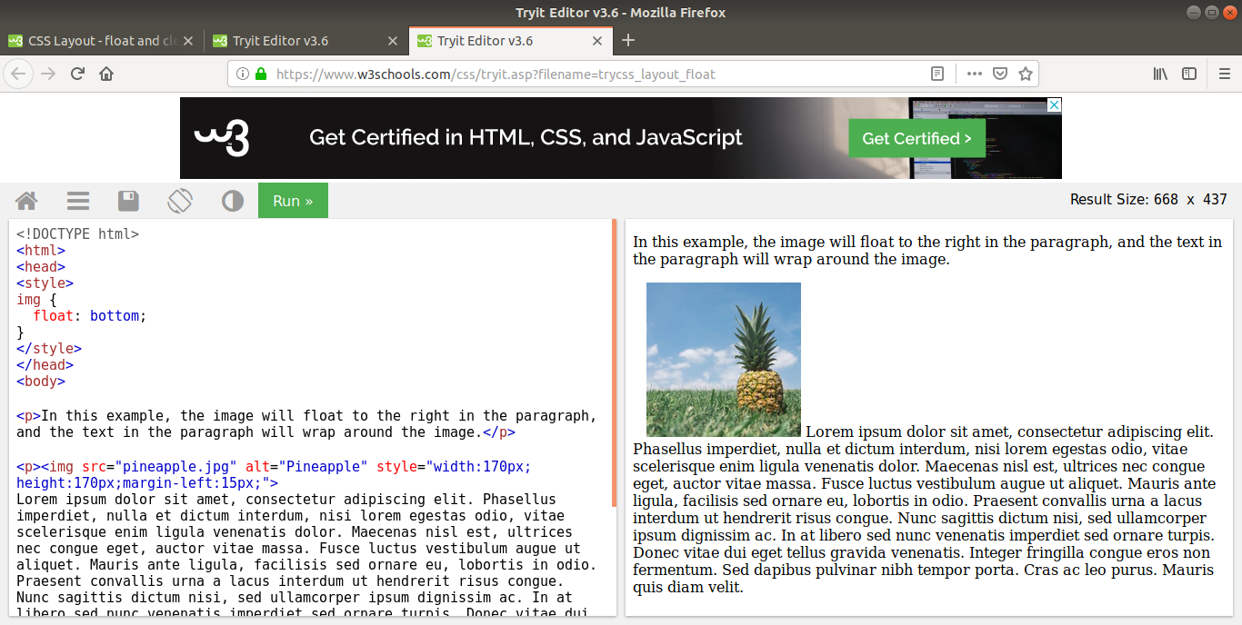

Clear property:

The clear property specifies what elements can float beside the cleared element and on which side.

The clear property can have one of the following values:

* none - Allows floating elements on both sides. This is default
* left - No floating elements allowed on the left side
* right- No floating elements allowed on the right side
* both - No floating elements allowed on either the left or the right side
* inherit - The element inherits the clear value of its parent

The most common way to use the clear property is after you have used a float property on an element.

When clearing floats, you should match the clear to the float: If an element is floated to the left, then you should clear to the left. Your floated element will continue to float, but the cleared element will appear below it on the web page.

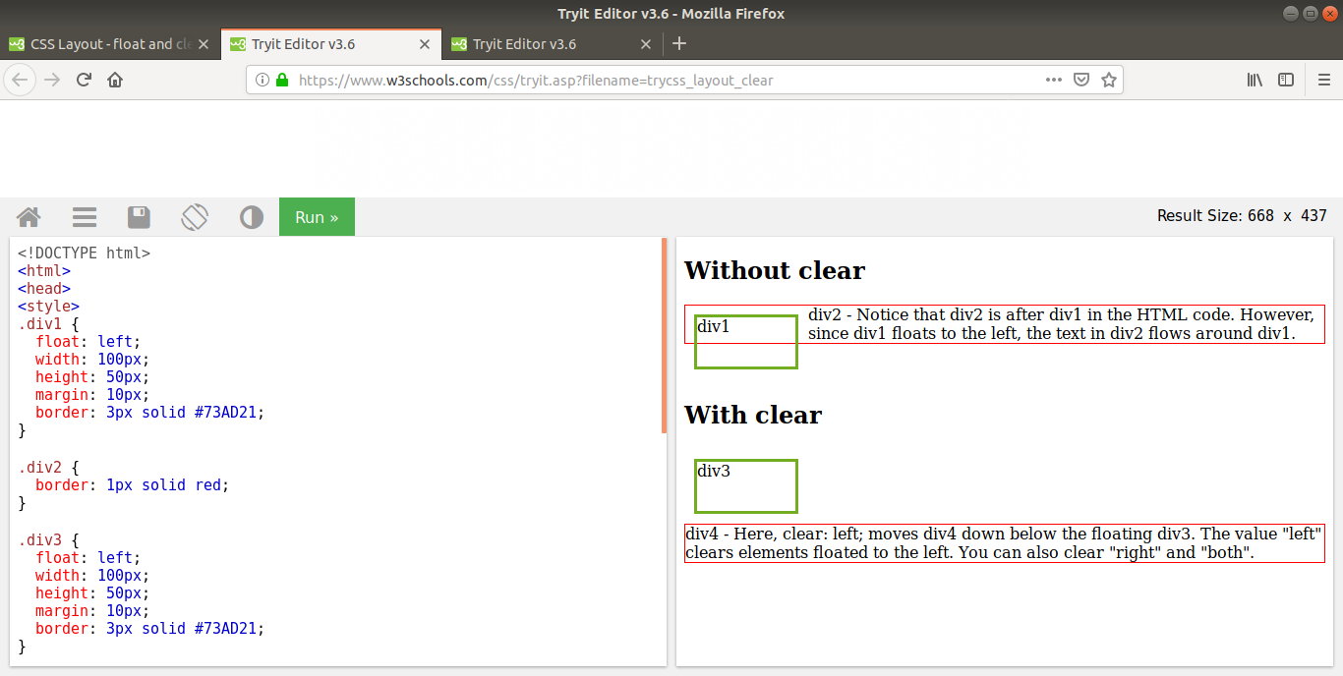

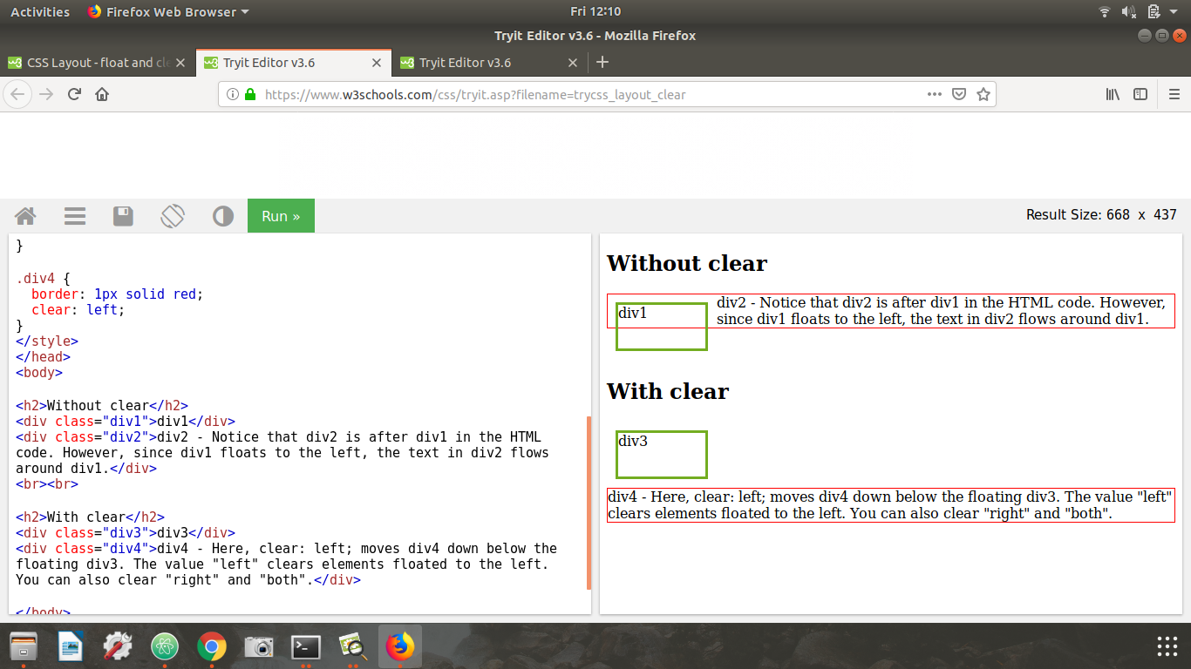

4. explain difference between absolute, relative,fixed and static.

Ans.

**The position Property**

The position property specifies the type of positioning method used for an element.

There are five different position values:

static

relative

fixed

absolute

sticky

Elements are then positioned using the top, bottom, left, and right properties. However, these properties will not work unless the position property is set first. They also work differently depending on the position value.

position: static;

HTML elements are positioned static by default.

**Static** positioned elements are not affected by the top, bottom, left, and right properties.

An element with position: static; is not positioned in any special way; it is always positioned according to the normal flow of the page:

**position: relative;**

An element with position: relative; is positioned relative to its normal position.

Setting the top, right, bottom, and left properties of a relatively-positioned element will cause it to be adjusted away from its normal position. Other content will not be adjusted to fit into any gap left by the element.

**position: fixed**;

An element with position: fixed; is positioned relative to the viewport, which means it always stays in the same place even if the page is scrolled. The top, right, bottom, and left properties are used to position the element.

A fixed element does not leave a gap in the page where it would normally have been located.

position: absolute;

An element with position: absolute; is positioned relative to the nearest positioned ancestor (instead of positioned relative to the viewport, like fixed).

However; if an absolute positioned element has no positioned ancestors, it uses the document body, and moves along with page scrolling.

**position: sticky**;

An element with position: sticky; is positioned based on the user's scroll position.

A sticky element toggles between relative and fixed, depending on the scroll position. It is positioned relative until a given offset position is met in the viewport - then it "sticks" in place (like position:fixed).

5. Write the HTML code to create a table in which there are 4 columns( ID , Employee Name, Designation, Department) and at least 6 rows. Also do some styling to it.

Ans

Html code:

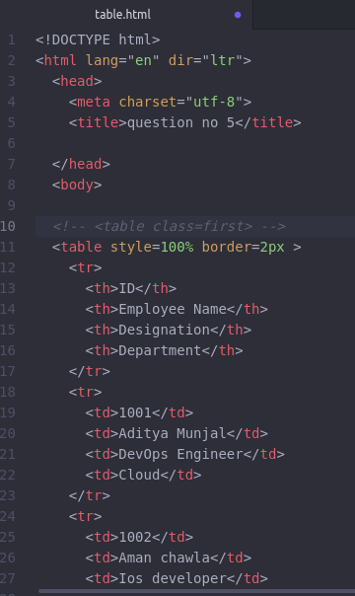

Output:

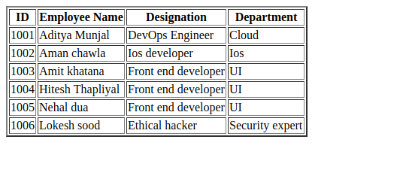

Doing some styling::

6. Why do we use meta tags?

Ans:The <meta> tag provides metadata about the HTML document. Metadata will not be displayed on the page, but will be machine parsable.

Meta elements are typically used to specify page description, keywords, author of the document, last modified, and other metadata. Also, it helps to improve the SEO( Search Engine Optimization) of a web page by using certain keywords related to the web page.

<meta> tags always go inside the <head> element.

Following are few examples of <meta> tag with different attributes :

<meta name="keywords" content="HTML, CSS, XML, XHTML, JavaScript"> (For Search engines)

<meta name="description" content="Free Web tutorials on HTML and CSS"> ( Description of web page)

<meta name="author" content="John Doe"> (Author of web page)

<meta name="viewport" content="width=device-width, initial-scale=1.0"> (Responsiveness)

7. Explain box model.

Ans

All HTML elements can be considered as boxes. In CSS, the term "box model" is used when talking about design and layout.

The CSS box model is essentially a box that wraps around every HTML element. It consists of: margins, borders, padding, and the actual content. The image below illustrates the box model:

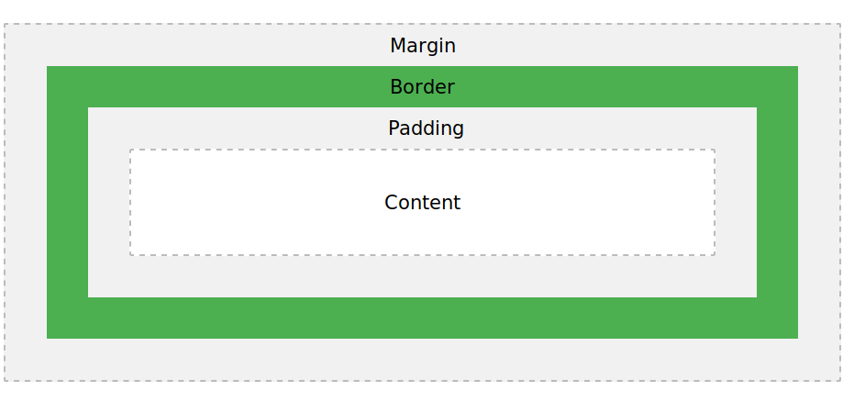

Explanation of the different parts:

* **Content** - The content of the box, where text and images appear
* **Padding** - Clears an area around the content. The padding is transparent
* **Border** - A border that goes around the padding and content
* **Margin** - Clears an area outside the border. The margin is transparent

8. What are the different types of CSS Selectors?

Ans

A CSS selector is the part of a CSS rule set that actually selects the content you want to style.

The **universal selector** works like a wild card character, selecting all elements on a page. Every HTML page is built on content placed within HTML tags. Each set of tags represents an element on the page. Look at the following CSS example, which uses the universal selector:

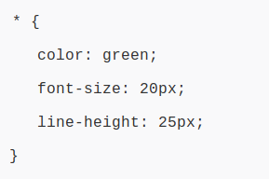

**Element type selector:**

Also referred to simply as a **“type selector**,” this selector must match one or more HTML elements of the same name. Thus, a selector of nav would match all HTML nav elements, and a selector of <ul> would match all HTML unordered lists, or <ul> elements.

The following example uses an element type selector to match all <ul> elements:

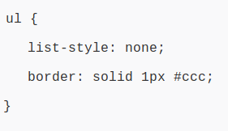

An **ID selector** is declared using a hash, or pound symbol (#) preceding a string of characters. The string of characters is defined by the developer. This selector matches any HTML element that has an ID attribute with the same value as that of the selector, but minus the hash symbol.

Here’s an example:

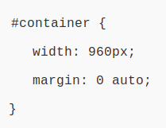

The **class selector** is the most useful of all CSS selectors. It’s declared with a dot preceding a string of one or more characters. Just as is the case with an ID selector, this string of characters is defined by the developer. The class selector also matches all elements on the page that have their class attribute set to the same value as the class, minus the dot.

Take the following rule set:

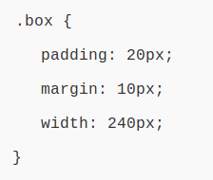

9. Define Doctype.

Ans.

The <!DOCTYPE> declaration must be the very first thing in your HTML document, before the <html> tag.

The <!DOCTYPE> declaration is not an HTML tag; it is an instruction to the web browser about what version of HTML the page is written in.

In HTML 4.01, the <!DOCTYPE> declaration refers to a DTD, because HTML 4.01 was based on SGML. The DTD specifies the rules for the markup language, so that the browsers render the content correctly.

HTML5 is not based on SGML, and therefore does not require a reference to a DTD.

10. Explain 5 HTML5 semantic tags.

Ans.

The **<section> element** defines a section in a document.

According to W3C's HTML5 documentation: "A section is a thematic grouping of content, typically with a heading."

A home page could normally be split into sections for introduction, content, and contact information.

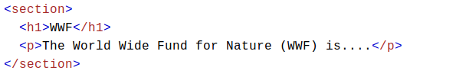

The **<article> element** specifies independent, self-contained content.

An article should make sense on its own, and it should be possible to read it independently from the rest of the web site.

Examples of where an <article> element can be used:

Forum post

Blog post

Newspaper article

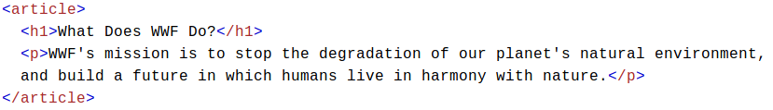

The **<header> element** specifies a header for a document or section.

The <header> element should be used as a container for introductory content.

You can have several <header> elements in one document.

The following example defines a header for an article:

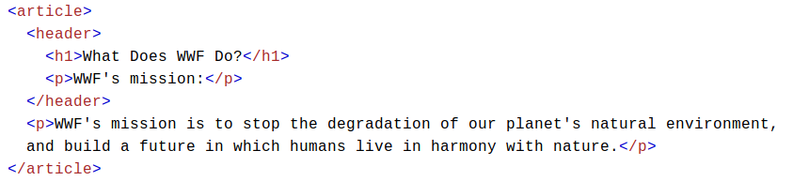

The **<footer> element** specifies a footer for a document or section.

A <footer> element should contain information about its containing element.

A footer typically contains the author of the document, copyright information, links to terms of use, contact information, etc.

You may have several <footer> elements in one document.

The **<nav> element** defines a set of navigation links.

The **<aside> element** defines some content aside from the content it is placed in (like a sidebar).

The <aside> content should be related to the surrounding content.

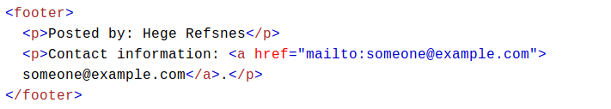

11. Create HTML for web-page.jpg (check resources, highest weightage for answers)

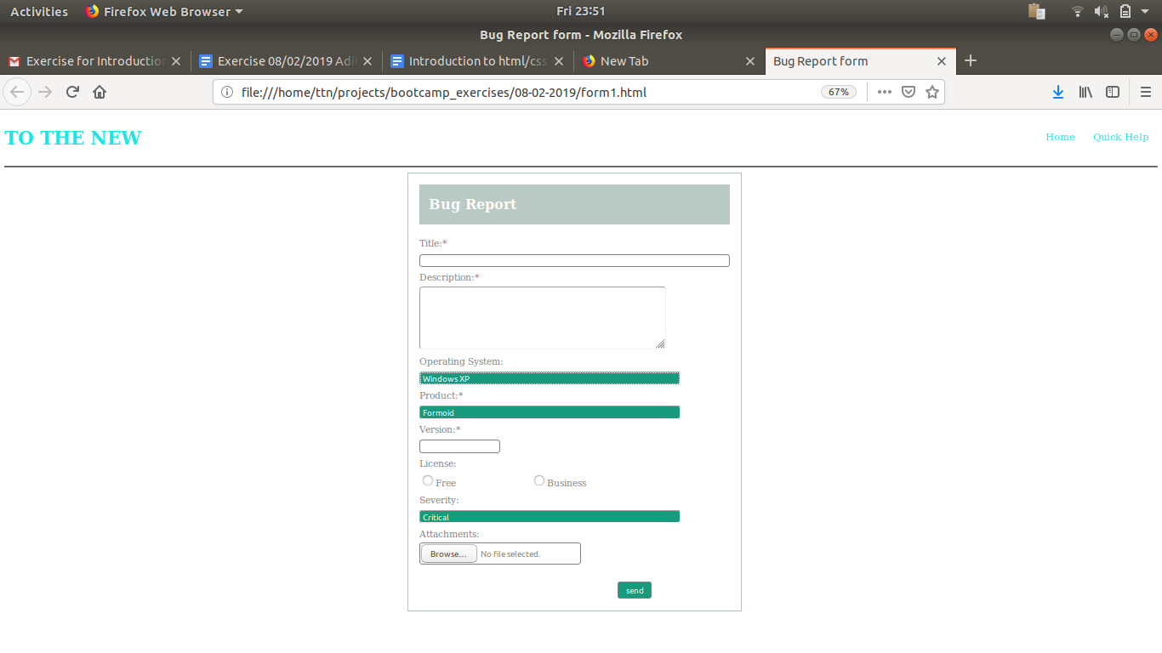

12. Create HTML for form.png (check resources, highest weightage for answers)

